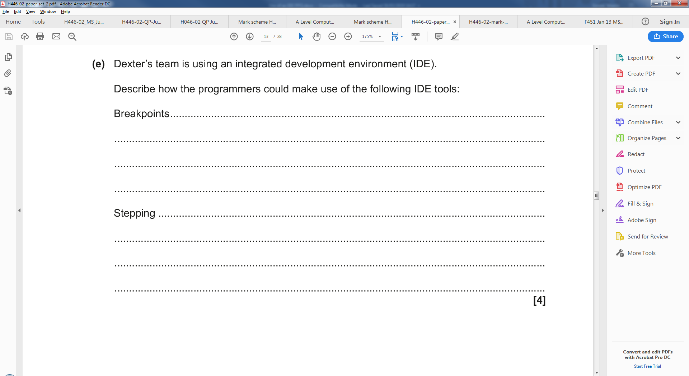

A programmer will use an IDE to debug his program during development.

Describe **three** features of an IDE that help debug the program. **Do not include Breakpoints or Stepping** [6]

|  |
| --- |
| 1. |
|  |
|  |
| 2. |
|  |
|  |
| 3. |
|  |
|  |